-- insert into table students Students(id,name,birthdate,gender,department)

-- values (110, 'Mary Jane', '20010512', 'Female') and department is the code of the department

-- named 'Business Administratio'

insert into Students(id,name,birthdate,gender,department) values(

110, 'Mary Jane', '20010512', 'Female',

(select d.Code from Departments d where d.Name ='Business Administration')

)

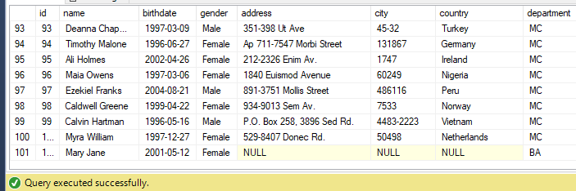

--In this query, the country of students who are enrolled in a department related to "Computer"

--and have enrolled in at least one semester in the year 2022 will be updated to "VietNam"

--because they have to study "Computer" in VietNam

UPDATE dbo.Students

SET country = 'VietNam'

WHERE department IN (

SELECT Code

FROM dbo.Departments

WHERE Name LIKE '%Computer%'

)

AND id IN (

SELECT studentId

FROM dbo.enroll

WHERE semesterId IN (

SELECT id

FROM dbo.semesters

WHERE year = 2022

))

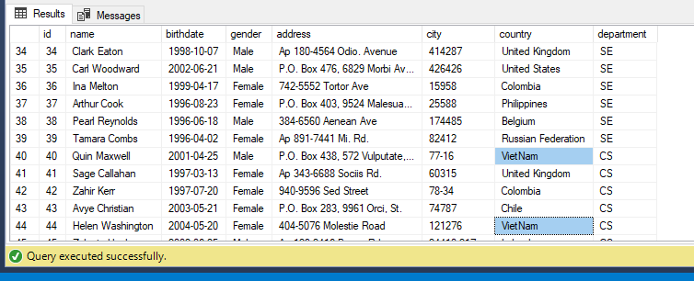

-- deletes students who are enrolled

--less than 2 courses and belong to the "Computer Science" department.

alter table enroll

drop constraint FK__enroll__studentI__44FF419A

DELETE FROM dbo.Students

WHERE id IN (

SELECT studentId

FROM dbo.enroll

WHERE semesterId IN (

SELECT id

FROM dbo.semesters

WHERE year = 2022

)

GROUP BY studentId

HAVING COUNT(DISTINCT courseId) < 2

)

AND department = 'CS'

